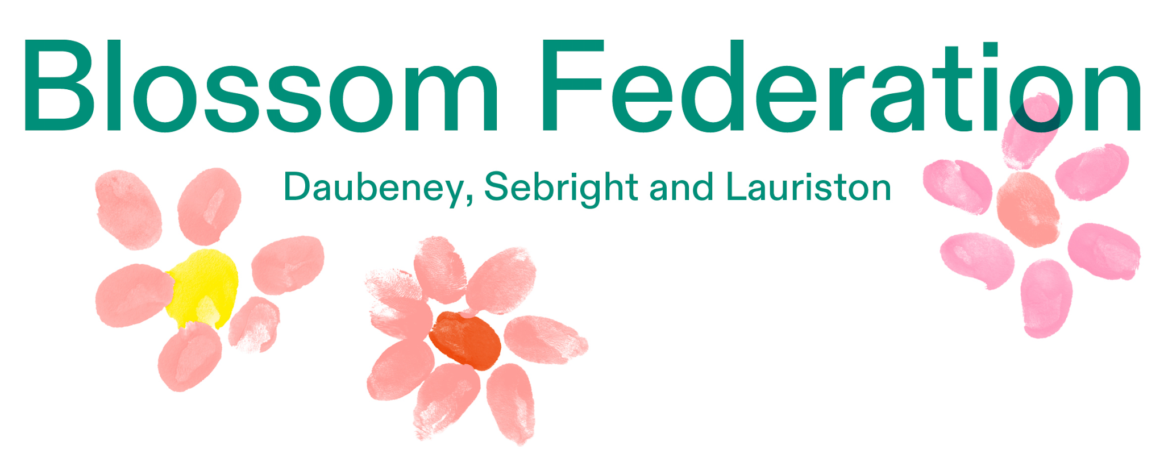
Term Dates 2025 - 2026
Autumn Term 2025
Wednesday 3rd September - Friday 24th October 2025 (38 days)

Half Term - Monday 27th October - Friday 31st October 2025

Monday 3rd November - Friday 19th December 2025 (35 days)

Spring Term 2026

Tuesday 6th January - Friday 13th February 2026 (29 days)

Half Term - Monday 16th February - Friday 20th February 2026

Monday 23rd February - Friday 27th March 2026 (25 days)
Spring Break - Monday 30th March - Friday 10th April 2026
Easter Break - Good Friday 3rd April - Easter Monday 6th April

Summer Term 2026

Tuesday 14th April - Friday 22nd May 2026 (28 days)

May Day - Monday 4th May 2026
Half Term - Monday 25th May - Friday 29th May 2026

Monday 1st June - Friday 17th July 2026 (35 days)

INSET DAYS
Monday 1st September 2025
Tuesday 2nd September 2025
Monday 5th January 2026
Monday 13th April 2026
Monday 20th July 2026

